**==========================================================**

**Web application**

**Lab 4 (week 5)**

# Goals:

The goal of Lab 4 is to develop a Web Application “Library system” with the given database “Library”.

# System description:

Your Library system must have the following functions:

1. Register members (add/edit/delete)
2. Register books and its copies (add/edit/delete)
3. Borrow a copy
4. Return a copy
5. Reserve a book

All requirements are described in document “List of sample projects”

# Sample web pages:

## 3.1. Home page

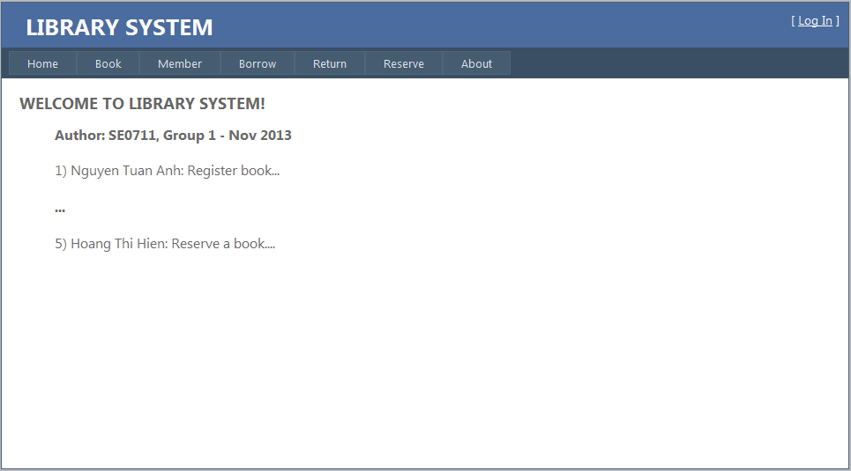

Requirements: Display name of class, group number and the list of members

## 3.2. Register books and copies

Interface Flow Diagram is shown as below

[Click Copies]

List of copies

List of books

(3.2

### 3.2.1. List of books

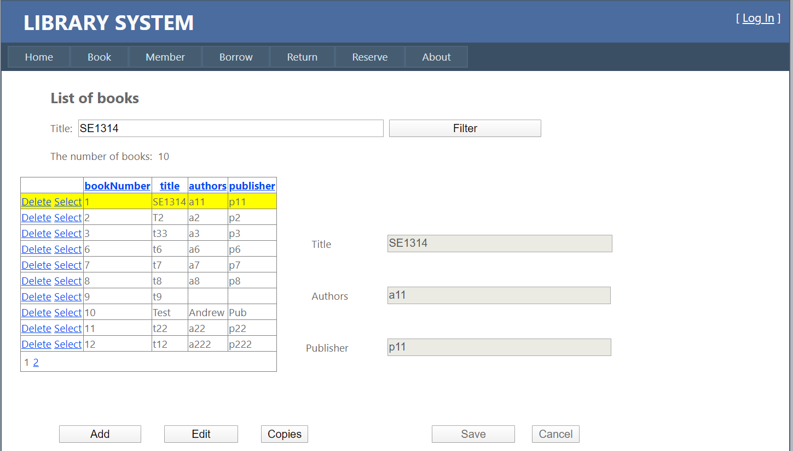

Requirements:

1. Enable sorting and paging in GridView.
2. The user can:
   1. Add a new book by clicking button “Add”, then you can enter a new book information. Click the button “Save” to save that new book into Database.
   2. Delete a book by clicking “Select”, then clicking “Delete” in the GridView.
   3. Edit a book by clicking “Select” in the GridView, then clicking the button “Edit”. You can enter book information. Click the button “Save” to update that book into Database.
   4. List all copies of a book by clicking “Select” of GridView, then click the button “Copies”. The “List of copies” page will be displayed
3. Note:
   1. The title must not be empty
   2. Book number is generated by the Database.

### List of copies

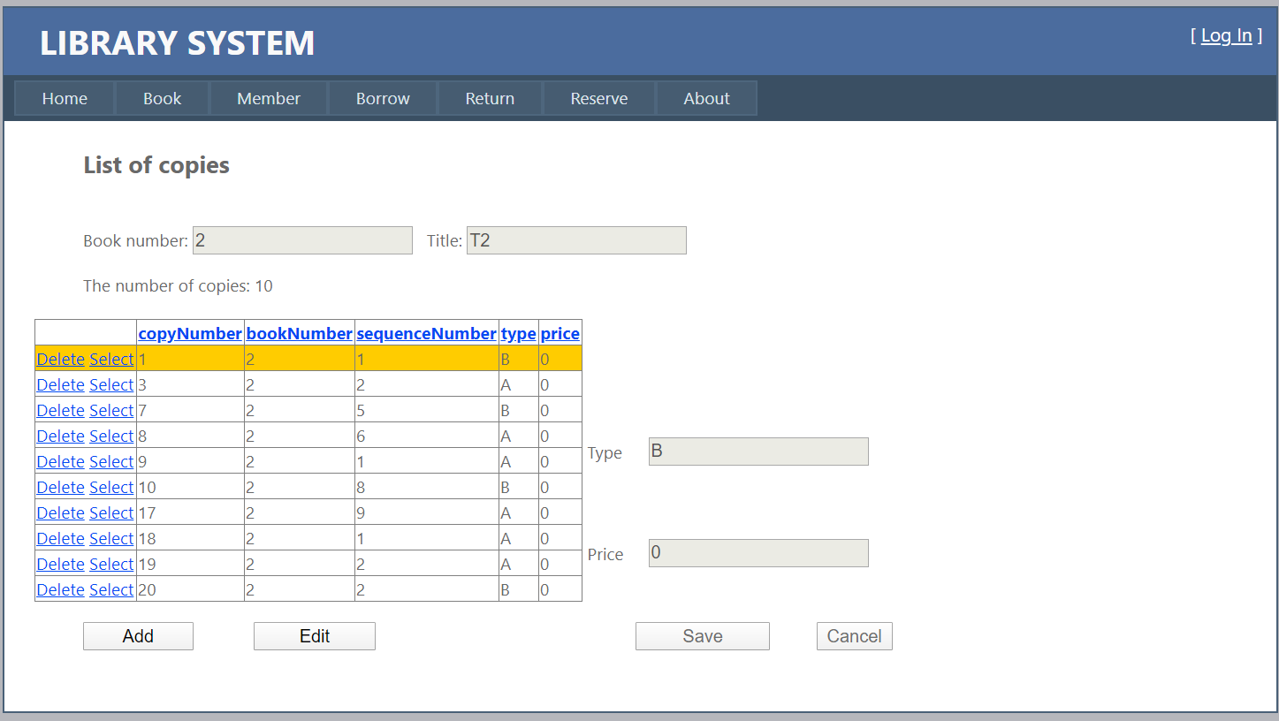

Requirements:

1. Enable sorting and paging in GridView
2. The user can:
3. Add a new copy by clicking the button “Add”, then you can enter a new copy information. Click the button “Save” to save that new copy into Database.
4. Delete a copy by clicking “Select”, then click “Delete” of the GridView.
5. Edit a copy by clicking “Select” of the GridView, then click button “Edit”, then you can update that copy information . Click the button “Save” to update that copy into Database.
6. Note:
7. The type must be ‘A’ or ‘R’.
8. The Price must be from 0 to 999.999.999.
9. Copy number, and sequence number are generated by the System.

## Register members

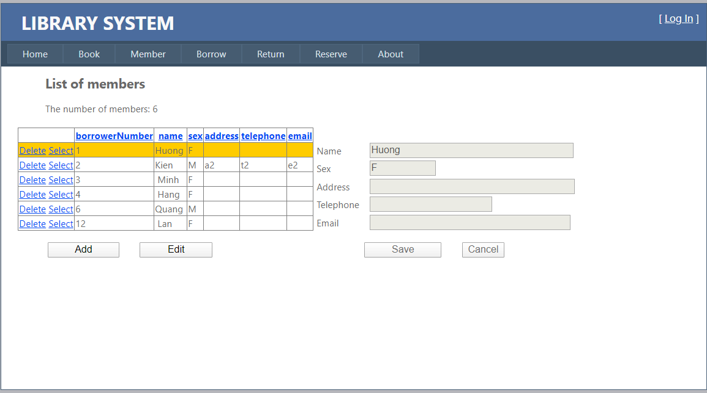

Requirements:

1. Enable sorting and paging in GridView
2. The user can:
3. Add a new member by clicking button “Add”, then you can enter a new member information. Click the button “Save” to save a new member into Database.
4. Delete a member by clicking “Select”, then click “Delete” of GridView.
5. Edit a member by clicking “Select” of the GridView, then click button “Edit”. You can update that member information. Click the button “Save” to update that member into Database.
6. Note:
   1. The Name must not be empty.
   2. The Sex must be ‘F’ or ‘M’.
   3. The Borrower Number is generated by the Database.

### Borrow a copy

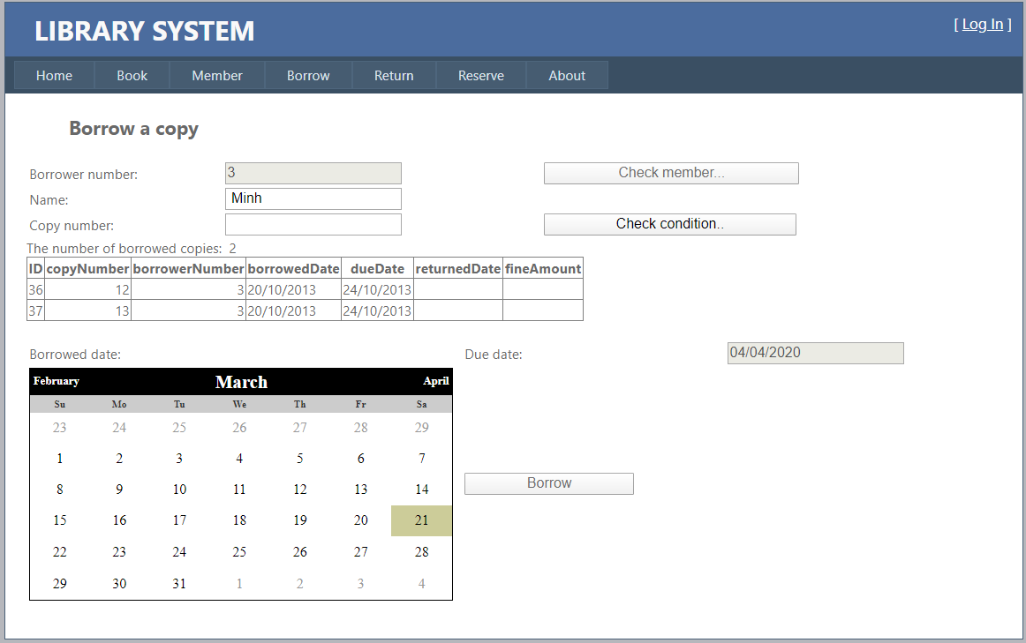

Requirements:

1. Check member by entering borrower number, then click button “Check member”:
   1. If this member is existed in Database, his/her name and the list of borrowed copies will be displayed and the user can move to step 2).
   2. If this member number is not existed in Database, error message will be displayed.
2. Check condition by entering copy number, then click button “Check condition”:
   1. If all condition described in requirements are satisfied, the user can move to step 3).
   2. If any condition is not satisfied, error message will be displayed.
3. Borrow this copy by choose the Borrowed Date, then click “Borrow” button.
4. Note:
   1. Set the current date of the system for Borrowed date as the default value.
   2. The Due Date is calculated by the System (14 days after the Borrowed date).

## Return a copy

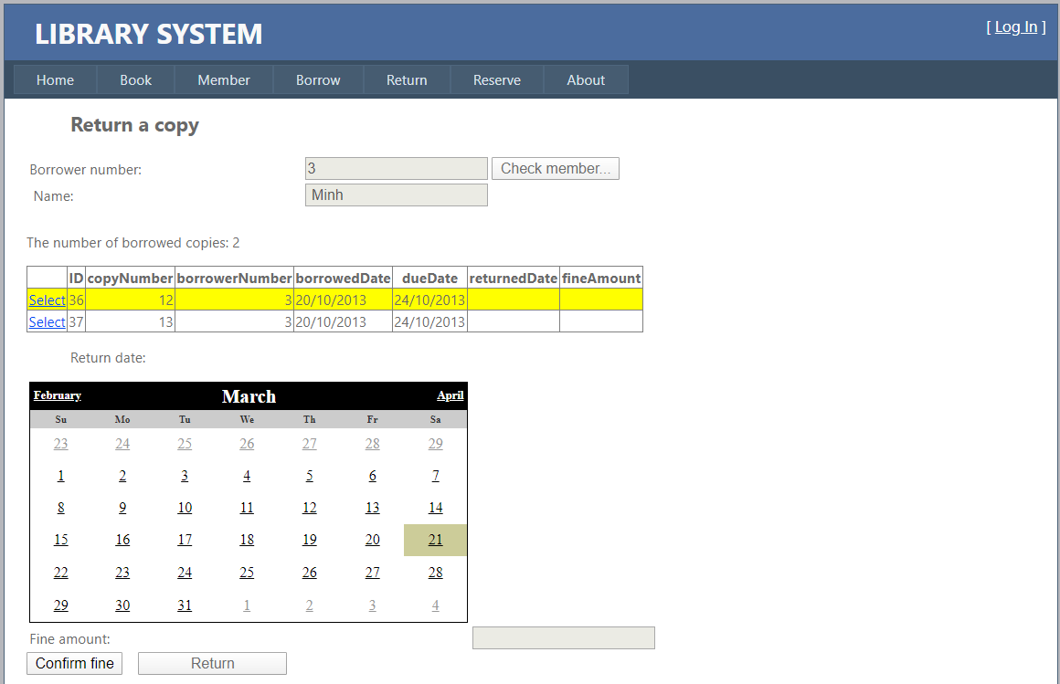

Requirements:

1. Check member by entering borrower number, then click button “Check member”:
   1. If this member is existed in Database, his/her name and the list of borrowed copies will be displayed and the user can move to step 2).
   2. If this member number is not existed in Database, error message will be displayed.
2. Calculate fine amount by clicking “Select” of the GridView, choose the returned date, then click button “Confirm fine”, the fine amount will be calculated by the System.
3. Click the button “Return” to return that copy.

## Reserve a book

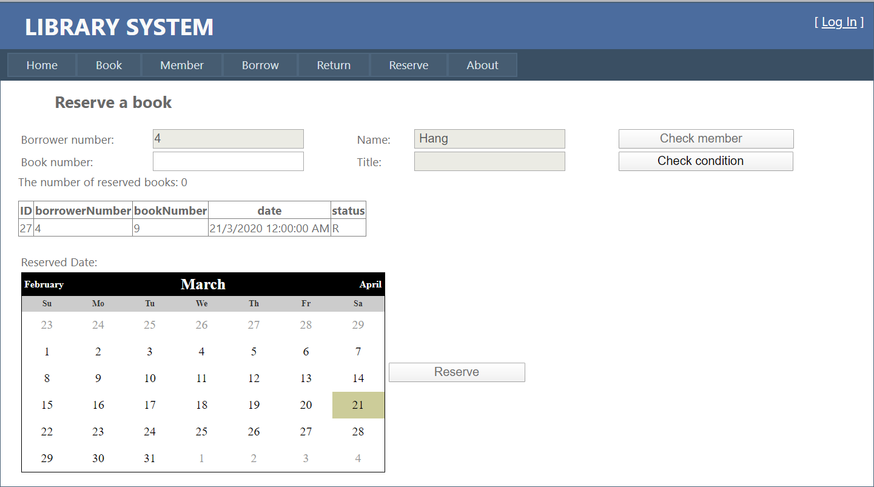

Requirements:

1. Check member by entering borrower number, then click the button “Check member”:
   1. If this member is existed in Database, his/her name and the list of his/her reservations will be displayed and the user can move to step 2).
   2. If this member number is not existed in Database, error message will be displayed.
2. Check condition by entering book number, then click the button “Check condition”:
   1. If all condition described in requirements are satisfied, the user can move to step 3).
   2. If any condition is not satisfied, error message will be displayed.
3. Choose Reserved date, then click the button “Reserve” to reserve that book.

# References:

1. How to use ObjectDataSource: http://msdn.microsoft.com/en-us/library/aa581783.aspx
2. Align right numerical values in GridView in ASP.NET: <http://blog.gsmodi.com/2010/11/aspnet-gridview-align-right-numerical.html>
3. Format date column in GridView: <http://forums.asp.net/t/1399403.aspx>
4. Converting HTML special characters in ASP.NET: <http://stackoverflow.com/questions/11336801/converting-html-special-characters-in-asp-net>
5. Change GridView selected row background color in asp.net: Set property BackColor of SelectedRowStyle in GridView to Yellow
6. [Get connection string using app.config file in C#](http://stackoverflow.com/questions/8707763/get-connection-string-using-app-config-file-in-c-sharp):

http://stackoverflow.com/questions/8707763/get-connection-string-using-app-config-file-in-c-sharp

# Note:

* + **Solution name:** Lab4_GroupN, where N = 1, or 2…
  + **File name** : ClassID_GroupN_Lab4.zip, where:
    - ClassID = SE0715, or SE0714…
    - N = 1 or 2…
  + **Connect string to connect Database must be stored in the file web.config**

“Server = localhost; Database = Library; Integrated Security = true”